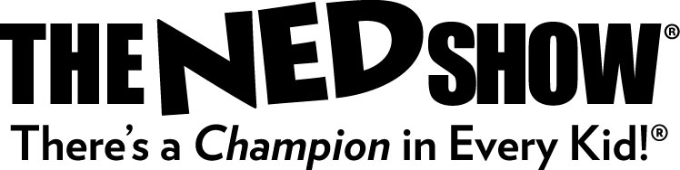
NEWS RELEASE

The NED Show Debuts Kid-Focused Bullying Prevention Resources
Lynnwood, WA – The NED Show recently released free resources that empower young students to recognize and stand up to bullying with four tips. These resources include a four-minute animated video, K-6 lesson plans and activities.
Working with schools since 1989, All for KIDZ, Inc., producers of The NED Show, is committed to Promoting Academic Achievement through Character Development®. The NED Show is a character education program that includes a 45-minute assembly and parent & teacher resources. The program centers around NED, a loveable cartoon character whose name is an acronym for Never give up, Encourage others, and Do your best®. It’s a simple, memorable message designed to teach valuable lessons that help kids become Champions at school and in life. They have seen nearly 25 million students and will visit more than 5,500 schools this year.
The 4-minute video, ‘You Can Be an Upstander,’ is a jump-start for classroom discussions about preventing bullying. Available at (http://www.thenedshow.com/upstander) and the video defines bullying in three following ways: someone chooses to feel cool or strong by being mean to people who are smaller or weaker (an imbalance of physical power), that the targets of bullying do not say or do anything in return (an imbalance of social power), and that the mean actions happen over and over (repetition). After bullying is defined in a kid-friendly manner, NED shows four solutions that any student can use to stop bullying right in it’s tracks:
1. Be a Buddy - Show the target of bullying that they have a friend.
2. Interrupt - Offer a distraction that interrupts the moment of bullying.
3. Speak out - Say something that communicates that bullying is not welcome.
4. Tell Someone - Whether it’s during the bullying or after it, tell an adult.
In addition to the video, educators can download the corresponding ‘Preventing Bullying’ lesson plans and other resources at no cost to support their efforts in changing school climate.
###
For further information about All for KIDZ contact Lois Hickman at 877-872-9696 x156.

Visit our website at www.theNEDshow.com
Download our Preventing Bullying Resources at www.thenedshow.com/preventing-bullying-lesson-plans.html

