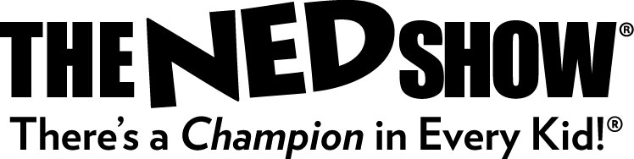
NEWS RELEASE

The NED Show®
Promoting Academic Achievement through Character Development®
City of School, State – Students and staff at (name of school) will experience America’s most popular school assembly on (day and date of show).
Inspiring more than 2.5 million students annually, All for KIDZ®, Inc. partners with schools in all 50 states, Canada, the United Kingdom, Australia and New Zealand. Their simple, yet impactful message is introduced through The NED Show, a 45-minute assembly that serves as a catalyst to enhance school climate.
With credentials that include performing at the White House eleven times, All for KIDZ has been sharing their unique form of character education for more than two decades.
Teaching three critical skills, the story of a loveable cartoon character NED® is designed to give students the tools they need to become Champions at school and in life. NED’s name serves as an acronym that makes the message easy to remember – Never Give Up, Encourage Others and Do Your Best®.
Audiences enjoy an engaging performance that focuses on the importance of persistence, kindness, diligence and excellence. Humor, audience participation, storytelling and amazing yo-yo tricks all combine to make it a truly NEDucational experience.
The NED Show’s message can stand alone or incorporate key themes such as school wide behavior programs, state testing prep or anti-bullying. Follow up curriculum and online resources for teachers, parents and students are provided to help reinforce the NED message following the show.
99% of the schools that invite NED to visit use the company’s Pay-It-Forward™ Program, an innovative approach that offers a solution to limited budgets and financial constraints. The program allows All for KIDZ to creatively partner with schools around the globe to bring The NED Show to schools at no cost.
Working with schools since 1989, All for Kidz, Inc. has seen more than 25 million students and will visit more than 6,000 schools this year.
For information about booking The NED Show visit www.theNEDshow.com or contact a NED Show representative at 877-872-9696.
###
For further information about All for KIDZ contact Lois Summers at 877-872-9696 x156.

